Brian Amond
Advanced Coach
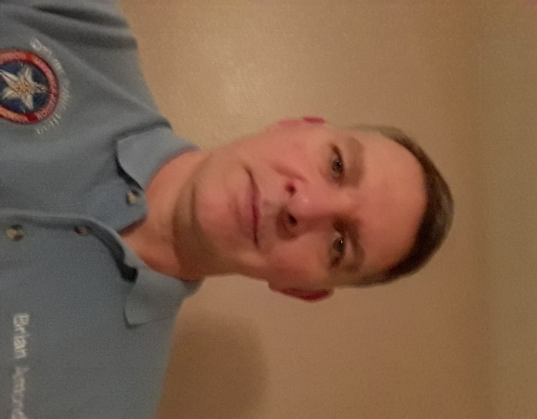

My involvement in MRPCA driving events began with Time Trial and AutoCross in the mid 1990’s driving 4-cylinder 914s of various displacements and even a genuine 914-6. After a few years I graduated to MRPCA’s Driver’s Education events and even attended a few Lonestar region DEs at TWS (RIP). The logical next step for me was PCA Club Racing. I earned my license in 2003 and raced for over a decade, in 996 GT3 Cup cars at first, eventually finding my home in the newly formed SpecBoxster class.

Not long after receiving my Club Racing license I was asked to be an instructor for the MRPCA DE program. I jumped right in to the AI role and never looked back. I wanted to share my passion for high-speed track events with like-minded individuals and help them progress in their driving careers like so many people had done for me. The look on a student’s face when they “get it” at the end of a track session is the best reward! While the majority of my driving has been in under-powered, mid-engined Porsches, I’m equally comfortable in 911s and higher horsepower cars (both Porsches and non-P-cars. My CR experience also allows me to offer insight and advice to those clients looking to join the ranks of PCA’s Club Racing program.
Carl Amond
Advanced Coach
My "need for speed" set in as a teenager and I tried the obligatory exploration of Drag racing, including some at the track. Early on I was pushing an '81 Vette with a "bought in a basket" 327 engine (14.0 in the quarter mile). One attempt at a parking lot gymkhana in the Vette started me looking for a 356. That search ended with a '62 Super 90 Cabriolet and the hook was set!
Five years of autocrosses, rallies and gymkhanas led up to my first SCCA Competition License in 1971 piloting a 997 Mini Cooper, ‘66 912,, ‘72 T Targa, '71 914-6 (I still have it), ’92 911
In 1992 joined the Maverick Region and got involved in Autocrosses and Time Trials. 1995 we bought a 914 "zoomie" (Blue Max) and my PCA Club Racing began. Throw in a few years of SVRA racing with a buddy in a right hand drive MGB for kicks. After a few years (and a few cars) racing GT3 Cup Cars, we discovered "Spec Boxster" and have been building, maintaining and racing these ever since.
When the DE program first started, we felt the need to pay back some of the great help we received from PCA friends over the years and the rest is history. I am still an active PCA racer (and SCUBA diver) and have been involved with the DE program since inception. The DE program is one of the best (and cheapest) "driver safety training" programs available, and I am proud to be a part of it. Drivers get to experience whatever level of exploring their car's limits they are comfortable with, and in the process learn to find the limits safely. Everyone gets to determine how hard they want to push and all will benefit for their entire lives from knowing that the options for dealing with an unexpected situation go well beyond "grab the wheel and brakes and pray". Best of all, we make new friends and have a lot of fun safely!

Pat Heptig
Maverick PCA Advanced Coach
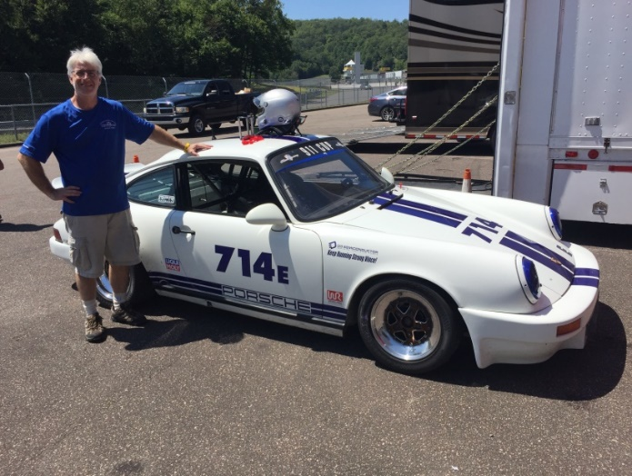
I have loved Porsches since I was a teenager. I guess that makes me a 57-year old Porsche nut who is also a 20-year Maverick PCA member. My very first DE was in 2006 with the Maverick PCA DE program. That DE changed my life. I was instantly hooked. I quickly moved to racing in the PCA Club Racing program in 2007. At that point, I was even more hooked and there was no looking back. I have been racing and instructing for the past 12 years and I love every second of it. I enjoy high performance driving because it requires your complete and absolute attention while you are on the track. There is no substitute.
I am also very active in the PCA Club Racing program, where I am one of the newest National Club Racing Stewards for PCA. I spend most of my track time racing my air-cooled 1987 911 Carrera (“E” class) in the PCA Club Racing program around North America. While I have owned, driven, and raced a variety of cars through the years (911, 944, GT3 Cup, and GT4), my heart lies with the air-cooled 911s. There is nothing like them.
I look forward to working with you to have a fun day at the track, learn more about your car and yourself, and to help increase your driving skills to the next level to find those precious increments of time on the track. See you at the track soon!

John Sandusky
Advanced Coach
I work with students to develop and refine skills they have to help them break through performance plateaus. I encourage students to make progress incrementally and consistently. I work with students to help them understand their driving situation including car performance and setup, and with understanding track nuances and conditions. I help them develop skills to evaluate their own driving.
I also work with students interested in participating in the coach training program and can provide information on the program and evaluations for prospective candidates.
PCA member since 1986. Experienced in all engine (front, mid, rear) and drivetrain (front, rear, AWD) configurations. Experience with many car brands and have coached with multiple clubs. Experience at many tracks. Experienced at helping students at all skill levels. Currently drive a track prepared Porsche 911 (964 series).
David Hodges
Advanced Coach
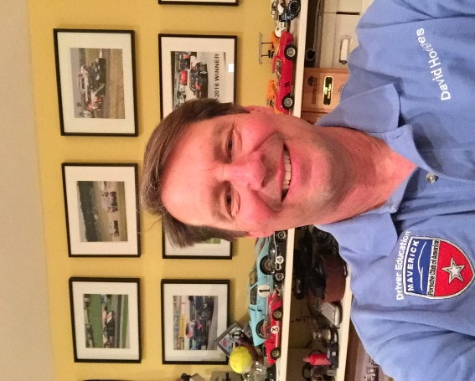
Name: David Hodges
Email: dmhodges911@gmail.com
Phone: 713-304-2557
Experience
Number of years DE: 15 years
Number of years racing: 10 years,+130 race starts
Number of years Coaching: 13 years

Organizations you Coach with and have Coached with: PCA, Eagles Canyon, Viper Days, BWM club
Tracks you have driven in the past few years:
Sebring, Barber, COTA, VIR, Road Atlanta, Watkins Glenn, Road America, Hallet, Highplains. ECR
Cars you have driven in the past few years:
2002 SP996, 2009 SP997, various Porsches, BWM’s, Mustangs, Corvettes.
Why do you Coach?
Coaching helps me to hone my skills, and to keep pushing to learn. One must have deep knowledge in order to teach a topic. I also enjoy introducing people to track day driving and helping them with the skills needed to be fast, safe and have fun.
Personal information and comments: I have earned a PCA National Club podium in 7 of the last 8 years. I have been a fan of motor sports forever and enjoy any day at the track. When not at the track I enjoy spending time with my wonderful wife and daughter.

Bret Gabriel
Advanced Coach

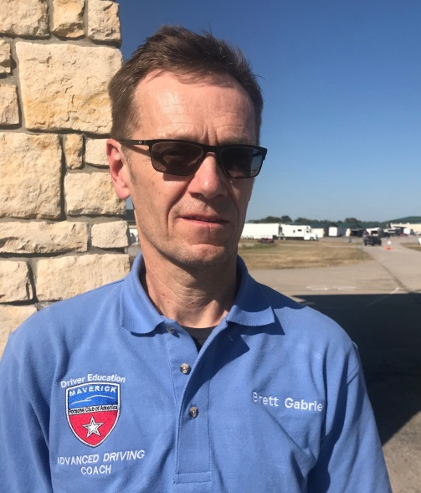

Name: Brett Gabriel
Email: brettgabriel@sbcglobal.net
Phone: 214-502-3244

Experience
Number of years DE: 15
Number of years racing: 10
Number of years Coaching: 12

Organizations you Coach with and have Coached with:

PCA, BMWCCA, Drivers Edge, Apex
Tracks you have driven in the past few years:
MSR Cresson, all configurations. MSR Houston, all configurations, Circuit of the Americas, Texas World Speedway, Texas Motor Speedway, Hallet, Eagles Canyon, Road Atlanta, Harris Hill
Cars you have driven in the past few years:
Race Experience in : Mazda Spec Miata, Porsche Spec Boxster, Porsche 996 GTC Cup
DE Experience in: BMW E46 M3, BMW E36 M3, Mazda Miata, Porsche 996 Carrera
Why do you Coach?
To share the desire and enthusiasm to explore the infinite learning opportunities in the physical and mental realm of motorsport, and the satisfaction that comes from helping others advance their skills and achieve their goals.
Jeff Wiggins
Advanced Coach



Name: Jeff Wiggins
Email: wiggins.jeffrey@verizon.net
Phone: 214 957 4385

Experience
Number of years DE: 14 yrs
Number of years racing: 12 yrs
Number of years coaching: 8 yrs

Organizations you Coach with and have coached with: PCA

Tracks you have driven in the past few years:
Road Atlanta, Watkins Glen, Barber, Mosport, Mont Tremblant, Road America, TWS, Hallett, Brainerd, VIR, MidOhio, Sebring, Brainerd, MSR, ECR, Cota, Nola, No Problem, Harris Hill, HighPlains and Heartland Park.
Cars you have driven in the past few years:
BMW E30, Porsche 911, Porsche 944, Camaro, Corvette, Porsche Panamera,
Porsche Cayman, Nissan 200sx, Porsche Boxster, Porsche Cayenne, Mazda
Why do you Coach?
For the Fun, Comradery and the Aha Sudden Realization Moments are priceless.
Personal information and comments:

100+ PCA Races, 33 Class Wins, 58 Podiums
Track records: ECR, Road Atlanta and Heartland Park.
Class-A Licensed transporting Race Cars across the US and Canada 4 years
PCA National Race Scrutineer
Married to the most wonderful person in the world!

Mark Gohlke
Advanced Coach
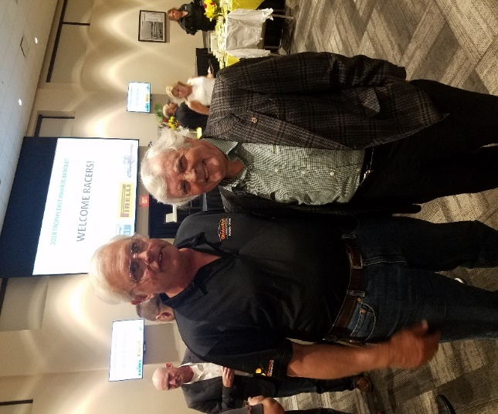

Name: Mark Gohlke
Email: rose.mark1980@myrhinomail.com
Phone: 972-670-8405

Experience
Number of years DE: 33
Number of years racing: 11
Number of years Coaching: 30

Organizations you Coach with and have Coached with: Maverick and Lone Star PCA
Tracks you have driven in the past few years:
MSR Dallas, Mosport, Hastings Nebraska, Hallett, NOLA, COTA, Road America (everyone must go there once), High Plains, Heartland Park, MSR Houston
Cars you have driven in the past few years:
The 914-6
Why do you Coach?
It’s fun and rewarding to help someone do well what they like to do.
Personal information and comments:
I dug my first car out of a snowbank when I was a teenager. The top was down so it was filled with snow, but no matter as the car also was not running. A ’59 TR-3 and the rest is history. I started doing autocross and time trials with PCA in 1989 or so. I instructed at TWS between about 1995 – 2005, and here (Dallas) since the start of the Maverick region DE program. I am interested in all sorts of cars. The current fleet includes a 59 TR-3, 64 356C, 73 911S, 99 Boxster, 18 GT3 touring car, 67 Corvette, 74 Lotus twin cam special and some of them even run.
I have been club racing a 72 914-6 in GT4 / VGTO class since 2009, and have vintage licenses with CVAR and SVRA. Club racing has taken me all over the country, including some bucket list tracks such as Road America and Mosport. I have 88 race starts so far.

Keith Olcha
Advanced Coach

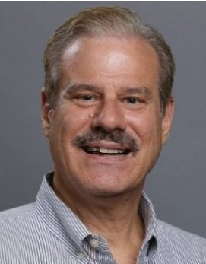

Name: Keith Olcha
Email: keith.olcha@verizon.net
Phone: (817) 706-7678
Experience
Number of years DE: 25
Number of years racing: 19
Number of years Coaching: 19

Organizations you Coach with and have Coached with:
Porsche Club of America
Classic BMW Client Coach
Tracks you have driven in the past few years:
Motorsports Ranch – 3.1, 1.7 CCW; 1.7 CW
Eagles Canyon
Circuit of the Americas
Texas World Speedway
Cars you have driven in the past few years:
Porsche Boxster; Porsche 964; Porsche Cayman; Porsche 991.1
Why do you Coach?
I learn something every time I’m in the right seat coaching on the track. I had great coaching when I wanted to learn high-performance driving. I want to help others the same way and add high-value to our program. My task is for my client to get the most out of their particular vehicle, in a safe and fun environment, at their pace to achieve their driving goals. These weekends should fun events that people look forward to attending!
Seth Higgins
Advanced Coach
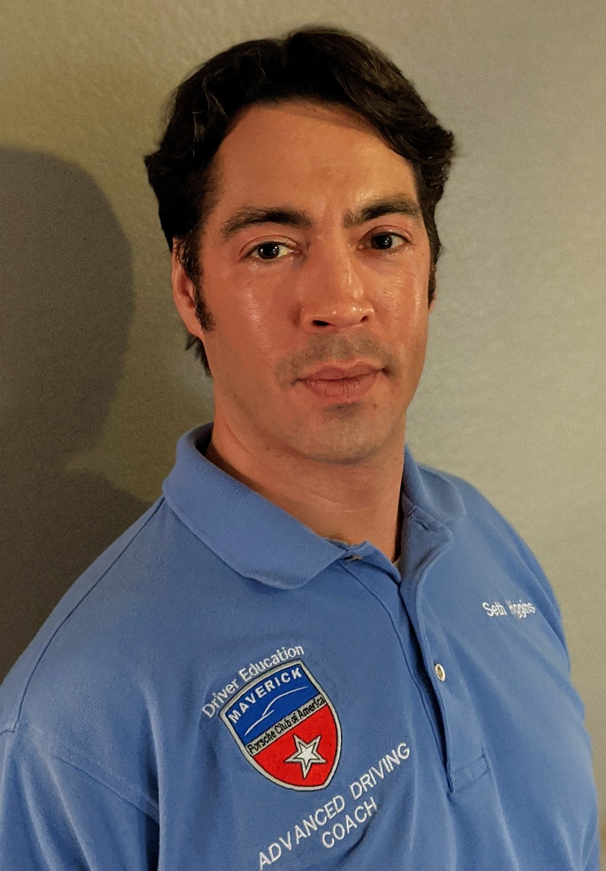

Name: Seth Higgins
Email: seth@khanakarts.com
Phone: 972-768-6262

Experience
Number of years DE: 16
Number of years racing: 15
Number of years Coaching: 14

Organizations you Coach with and have Coached with:

Apex Academy, Aston Martin N.A., BMW CCA, Classic BMW, Corinthians Vintage Auto Racing, Eagles Canyon, PCA, Teen Street Survival, and private coaching

Tracks you have driven in the past few years:

COTA, ECR, Hallett, MSR Cresson, NOLA, NPR, TWS, TMS, PBIR, Willow Springs

Cars you have driven in the past few years:

‘98 Spec Boxster, ‘73 RSR, ‘02 GT3 Cup, ‘74 Carrera, ‘96 Carrera, ‘95 240SX, ‘14 M235i, ‘10 V8 Vantage, ‘14 A4 Quattro

Why do you Coach?
To attack the problems of racing from different perspectives. To help people have fun. And, to help the sport.

Personal information and comments:

For practicing car control and drifting at home between events, I developed a drift-kart. It’s designed to boost learning at minimal cost. In 2013, I started Khana Karts LLC to provide kits and full builds. While there are many drift-trikes available, I provide the only consumer-focused 4-wheeled RWD drift-kart.

For real work, I lead network deployment design automation at Google. I’ve been there 7 years and previously worked at Adva, Cisco, and Sprint.

Besides work and motorsports, my wife and I have two teenagers. And, I enjoy games, particularly The Battle of Polytopia.

RAFAEL SERRALTA
Advanced Coach

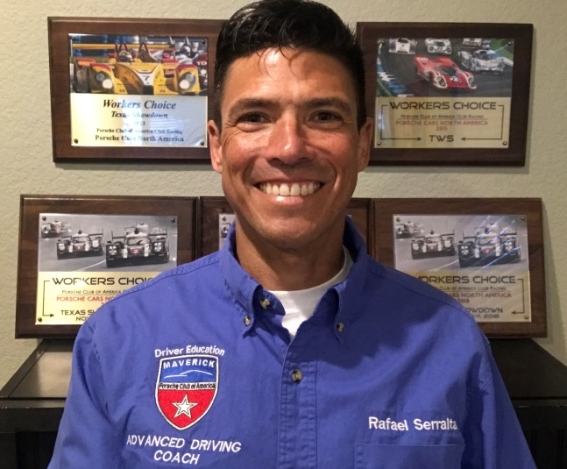
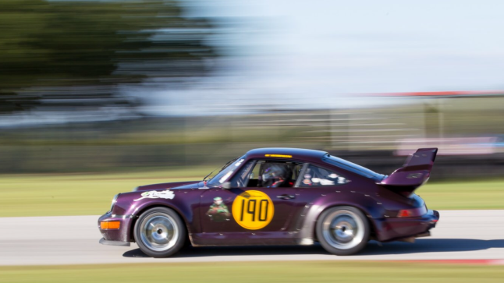
RAFAEL SERRALTA
Coaching Philosophy
- Determine an individual’s session goal and work towards it in a safe and enjoyable method.
- Observe, assess and collaboratively suggest different approaches or techniques with a core emphasis on the “why”, not just the “what”.
- Ensure that we all have fun in the quest for improvements. We are all on a race track because of passion for the sport.
Driving History
- Learned how to drive in 1974 at age 6 in Mexico in air-cooled Volkwagen Beetles (bored family members thought it would be fun…)
- Racing officially began in college (1986-1991) as a Design Engineer and primary driver for national champion Formula S.A.E. racing team (University of Texas Arlington).
- Began avid and consistent participation with PCA DE program in 2008.
- Became National Certified PCA Instructor in 2012.
- PCA Racer in GT3 – GT4 Class since 2013 with many successful races and multiple recipient of Corner Worker’s Choice Award.
- Instructor for various Driving Schools (Driver’s Edge and Eagles Canyon Raceway)
- Motorsport Safety Foundation certified instructor.

